***College logo College Logo whitecode logo***

***Miraj Mahavidhyalay Miraj***

***and***

***S.M Dnyandeo Mohekar Mahavidyalaya, Kalam***

***Organized Two Days National Level Webinar***

***on***

***“AQAR WRITING AND SUBMISSION AS PER NEW NAAC GUIDELINES”***

***6th June 2020 to 7th June 2020***

***This is to certify that***

*Mr. Sandip Nanaware from ABC College*

*Has participated in the national webinar from 6th June 2020 to 7th June 2020 for 6 hours | cert.ID…….*

***Signatures***

1st : Dr. Chandrashekhar Karande, Principal (Miraj Mahavidhyalay Miraj)

2nd: Smt. Shubhangi Patil, Coordinator (Miraj Mahavidhyalay Miraj)

3rd: Dr. Sunil pawar, Principal, SMDMM

4th: D r. Kamlakar Jadhav Coordinator SMDMM

5th: Amit Patil, CEO, whitecode

**Signatures:**

Dr. Chandrashekhar Karande



Smt. Shubhangi Patil

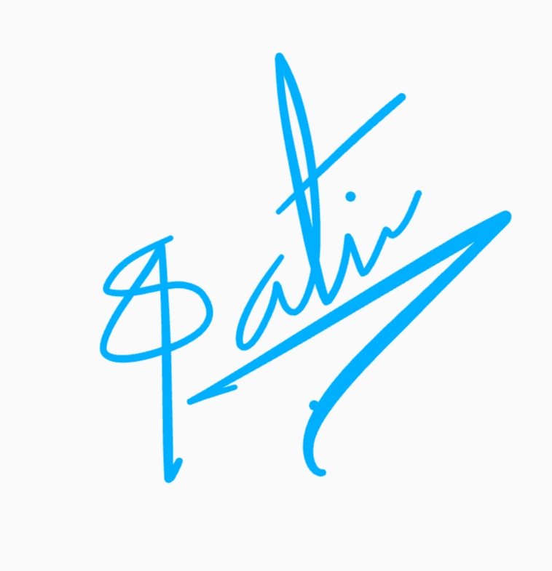

Logo

